***SERVICE BOOKING ARCHITECTURE***

By: **Samuel Iso** (samdoxiso@gmail.com)

Company: ***Samsojac Concepts Services Nigeria Ltd*** | *Pandaville Labs*

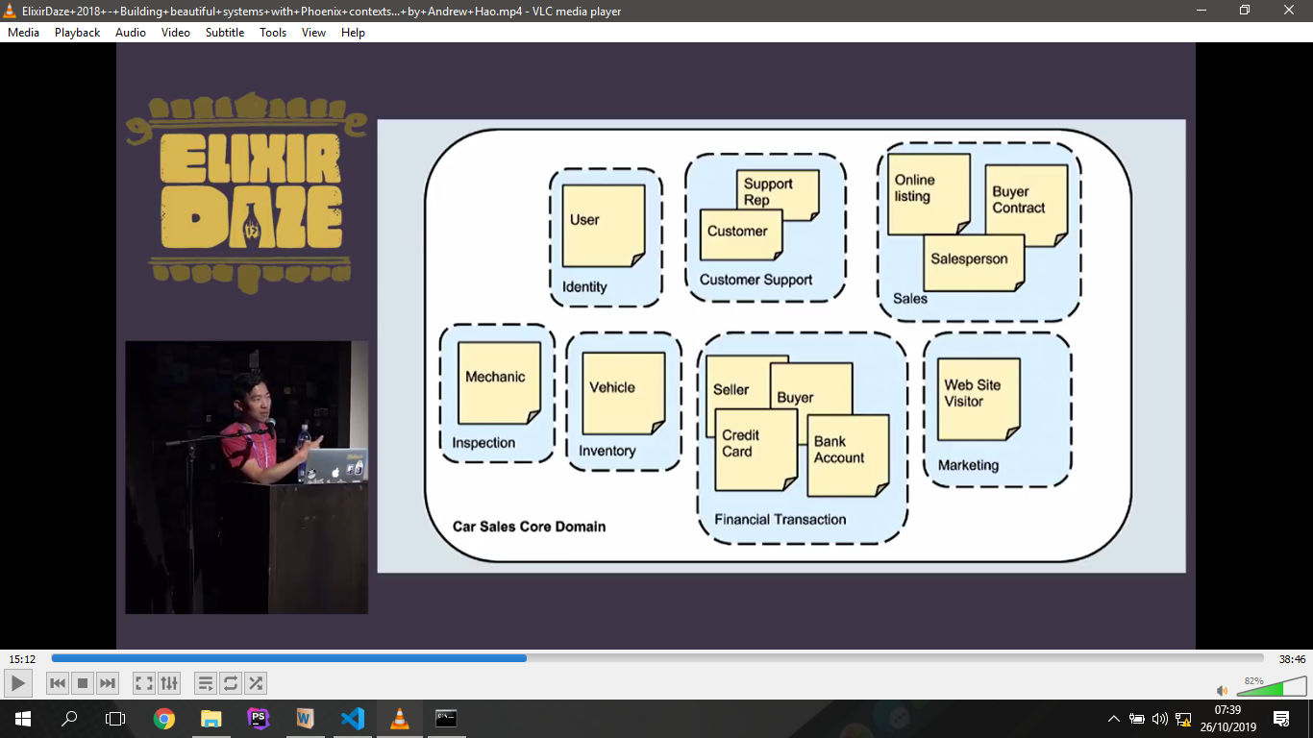

|  |  |  |
| --- | --- | --- |
| **Sales**  Service_Listing  Service_Providers  Service_Consumers  Service_Orders | **Finance**  Seller/Merchant  Buyer  Wallet[Account]  Gift_Card | **Identity**  User(Aggregrate root with Profile)  Marketing  Loyalty_Rating |

Proposal -

Website for booking Session(Service) more details than mobile app

Payment Platform - Client can pay. Book and Pay on Website or In Saloon

Loyalty programme: booking confirmed - loyalty goes up per completion of service-

Gift Card -

Someone who pays online _ someone can pay into virtual/wallet account

Mobile App - cost

SERVICE BOOKING ARCHITECTURE

BY: SAMUEL ISO (samdoxiso@gmail.com)

COMPANY: Samsojac Concepts Services Nigeria Ltd | Pandaville Labs

**ACTORS**

* ServiceProvider
* Consumers
* Admin

**ENTITIES**

Consumer{user_uuid, name} <= [Service.Consumers]

Provider|ServiceProvider {user_uuid, name} <= [Service.Providers]

Services {owner_uuid, name, %tags{}, description, %details{description,thumbnail...}} <= [Service]

Orders {uuid, %consumer{}, created_at, %when(from_date, to_date), %where{%address{}}, %order_events[timestamp, %status]}

Invoice{uuid,order_uuid, total, %line_items[], %payment_events[%payment{},timestamp, %status] }

Payments{uuid, invoice_uuid, from_account_uuid, to_account_uuid}

Accounts{uuid, class_account_uuid, name, opening_balance, current_balance}

User {uuid, handle, %login_details{}, created_at} <= [Identity.Security]

Profile {uuid, %profile_details{%profile_photos{}, email, phone, %home_address{}, %scoring{loyalty}}} <= [Identity.Profiles]

COMMANDS {_transaction_id, timestamp} in every command internally used

login{%login_details{}, %login_method}

register_user {%user{}}

create_user_account{%user, %account} => %Account{}

profile_user{%user, %profile{}}

create_service{%provider, %service{}} ==> %Order{}

Update_Service {

request_service{%service, %requests}

accept_service{%serviceprovider, %order_event{ACCEPTED}}

reject_service{%serviceprovider, %order_event{REJECTED}}

cancel_service{%serviceprovider, %order_event{CANCELLED}}

confirm_service{%serviceprovider, %order_event{CONFIRMED}}

} ==> %Order{} #New Order state

generate_invoice{%order, total, %line_items[] %} ==> %Invoice{}

pay_invoice{%invoice, amount} ==> %Invoice{%payment_events{%payment{%from_consumer, %to_provider, amount}, PARTIAL/FULL}}

DOMAINS[CONTEXT] (sub-domains)

* Identity (security, profile)
* Service (service_requests)
* Finance (billing, gift_card, )
* Rewards (loyalty,)

**ACTIVITIES/COMMANDS**

* Registration: marks the person as a basic user (default) or service_provider
* Authentication&Authorization
* Sales
* Payments

**EVENTS**

* order_events
* invoice_events